**INDUSTRIAL INTERNSHIP PROJECT REPORT**

**REPORT**

Submited by

**R.T.MONIKA**

**ANNAI VAILANKANNI COLLEGE OF ENGINEERING**

AVK Nagar, Pottalkulam, Azhagappapuram Post,

Kanyakumari District - 629401

**ANNA UNIVERSITY: CHENNAI 600025**

AUGUST- 2024

**ANNAI VAILANKANNI COLLEGE OF ENGINEERING**

AVK Nagar, Pottalkulam, Azhagappapuram Post,

Kanyakumari District - 629401

**DECLARATION**

I**, R.T.MONIKA** hereby declare that the internship entitled “WEB DEVELOPMENT” undergone at “**WORKCOHOL SOLUTIONS PRIVATE LIMITED,TARAMANI,CHENNAI**” being submitting my project “**Ecommerce Gaming Accessories Site**” in Software Development Intern. This is the original work carried out by me.

iii

**LIST OF FIGURES**

|  |  |  |
| --- | --- | --- |
| **FIG. NO** | **TITLE OF FIGURES** | **PAGE. NO** |
| 4.1.1 | Overview of the ecommerce website design |  |
| 4.1.2 | Entity Relationship Diagram |  |
| 4.1.3 | Category Page |  |
| 4.1.4 | Product and Description Page of the E-Commerce website |  |
| 4.1.5 | Signup/Login an Cart Page of the E-Commerce website |  |

**LIST OF ABBREVATION’S**

### **Frontend Abbreviations**

| **Abbreviation** | **Full Form** |
| --- | --- |
| **HTML** | **-** HyperText Markup Language |
| **CSS** | **-**  Cascading Style Sheets |
| **JS** | **-** JavaScript |
| **JSX** | **-** JavaScript XML |
| **DOM** | **-** Document Object Model |
| **UI** | **-** User Interface |
| **UX** | **-** User Experience |

### **Backend Abbreviations**

| **Abbreviation** | **Full Form** |
| --- | --- |
| **API** | **-** Application Programming Interface |
| **REST** | **-** Representational State Transfer |
| **CRUD** | **-** Create, Read, Update, Delete |
| **DB** | **-** Database |
| **SQL** | **-** Structured Query Language |
| **JWT** | **-**  JSON Web Token |
| **ORM** | **-** Object Relational Mapping |

**TABLE OF CONTENT**

|  |  |  |  |
| --- | --- | --- | --- |
| CHAPTER NO | TITLE | PAGE NO | |
|  | **Certificate** |  | |
|  | **Company Certificate** |  | |
|  | **Declaration** |  | |
|  | **List of Figures** |  | |
|  | **List of Abbreviation** |  | |
| 1. | **Introduction** |  | |
|  | 1.1 Background |  | |
|  | 1.2 Objectives |  | |
|  | 1.3 Scope |  | |
| 2. | **Profile** |  | |
|  | 2.1 Industry Profile |  | |
|  | 2.2 Industry Culture |  | |
| 3. | **Internship Details** |  | |
| 4. | **Project** | |  |
|  | 4.1 E-Commerce Website | |  |
| 5. | **Skills Acquired** | |  |
| 6. | **Conclusion** | |  |

**INTRODUCTION**

**Web development** is the process of creating and maintaining websites and web applications that are accessible through the internet or an intranet. It involves a combination of programming, design, and problem-solving to build interactive and friendly digital experiences.

**Background and Objectives:**

The gaming industry has experienced explosive growth in recent years, driven by the increasing popularity of eSports, streaming, and advanced gaming consoles and PCs. With this surge in demand, gamers are constantly seeking high-quality accessories such as gaming headsets, mechanical keyboards, ergonomic chairs, and custom controllers to enhance their performance and overall gaming experience.

Despite the growing market, many online platforms lack a specialized, user-friendly, and dedicated shopping experience tailored specifically to gamers. This gap presents a valuable opportunity to create an eCommerce platform that not only offers premium gaming accessories but also builds a community around the gaming lifestyle.

The main objectives of this eCommerce website for gaming accessories are:

1. **To provide a dedicated online store** for high-quality and curated gaming accessories from trusted brands.
2. **To ensure a user-friendly and responsive interface** that allows gamers to easily browse, compare, and purchase products across all devices.
3. **To integrate secure and seamless payment methods** for a smooth checkout experience.
4. **To include product reviews, ratings, and detailed specifications**, helping users make informed purchasing decisions.
5. **To implement personalized recommendations** based on user preferences and browsing history.
6. **To offer fast and reliable delivery options**, including order tracking and customer support.
7. **To build a brand identity that resonates with the gaming community**, incorporating engaging visuals, themes, and content.

**PROFILE**

**Industry Profile:**

**WORKCOHOL SOLUTIONS PRIVATE LIMITED,**is leading organization focused on advancing technological innovation and skill development in the **IT and software development sector**. With a strong emphasis on creating industry-ready professionals and fostering digital transformation, Workcohol operates as both a training hub and a solutions provider, delivering cutting-edge expertise across various domains

**Work Culture:**

The work culture at the TANSAM Centre of Excellence likely reflects a dynamic, innovative, and collaborative environment, given its focus on rapid development and advanced learning. Here's what can typically characterize such an organization's culture:

**1. Innovation-Driven**

* Emphasis on creative problem-solving and encouraging new ideas.
* Open-mindedness towards adopting cutting-edge technologies and methodologies.

**2. Skill Development Focus**

* Strong support for personal and professional growth, including training programs, mentorship, and hands-on projects.
* A focus on competency-based learning to ensure participants are industry-ready.

**3. Collaboration and Teamwork**

* Teamwork across diverse skillsets to achieve excellence in projects.
* Open communication channels to share insights and feedback.

**5. Inclusivity and Diversity**

* Setting high expectations for performance and outcomes.
* Recognition of achievements and contributions to motivate individuals.

**4. High Standards and Accountability**

* Creating a supportive environment that values diverse perspectives.
* Encouraging equal opportunities for everyone

**PROJECT**

**4.1.1 Overview of the ecommerce website design**

The eCommerce system design typically involves a modular architecture to facilitate seamless interaction between the user interface, business logic, and data layers. Below is an overview of a typical eCommerce system design.

This eCommerce website is a specialized online platform designed to cater to the needs of gaming enthusiasts by offering a wide range of high-quality gaming accessories. The site provides an immersive shopping experience tailored to the gaming culture, featuring products such as gaming keyboards, headsets, mice, controllers, chairs, and other peripherals.

The platform aims to combine functionality with style, delivering a visually appealing interface that aligns with the aesthetics of modern gaming. It is built with responsive design principles to ensure optimal performance across desktops, tablets, and mobile devices.

Key features of the website include:

* **Product Catalog:** Well-organized and filterable listings of gaming accessories with detailed descriptions, images, and specifications.
* **User Accounts:** Registration and login system to manage user profiles, orders, and preferences.
* **Shopping Cart and Secure Checkout:** A seamless and secure process for adding products, applying discounts, and completing purchases.
* **Search and Recommendation Engine:** Smart search functionality and personalized product suggestions based on user behavior.
* **Customer Reviews and Ratings:** Community-driven feedback to help users make informed decisions.
* **Order Tracking:** Real-time updates on shipping and delivery status.

The goal of this website is not just to sell products but to create a digital hub for gamers looking for reliable gear, great deals, and a seamless online shopping experience tailored to their needs.

**4.1.1 SIGNUP/LOGIN PAGE:**

Login Form: The login form typically includes fields for entering the username/email and password. There should be options for users to show/hide their password and to retrieve forgotten passwords.

CTA Button: A prominent "Login" button should be clearly visible. The button should be styled to match the website’s design and encourage users to click.

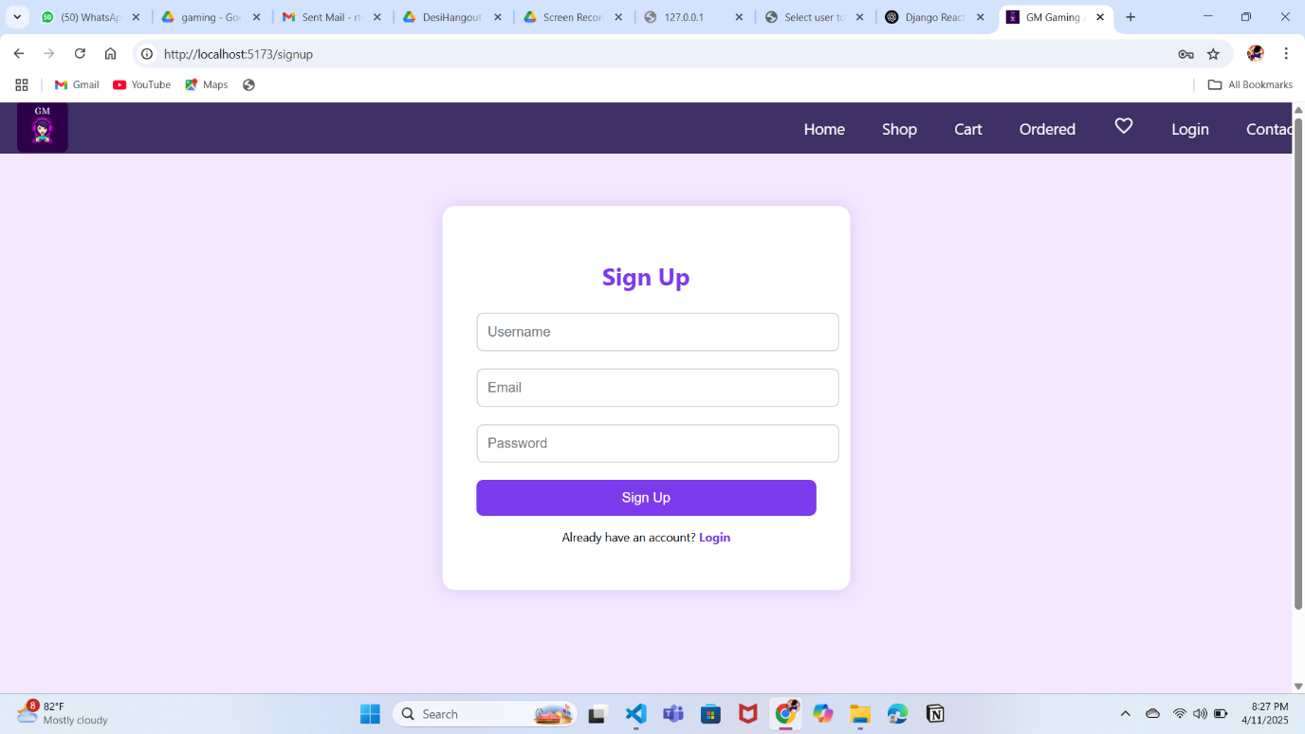

**4.1.2 HOME PAGE:**

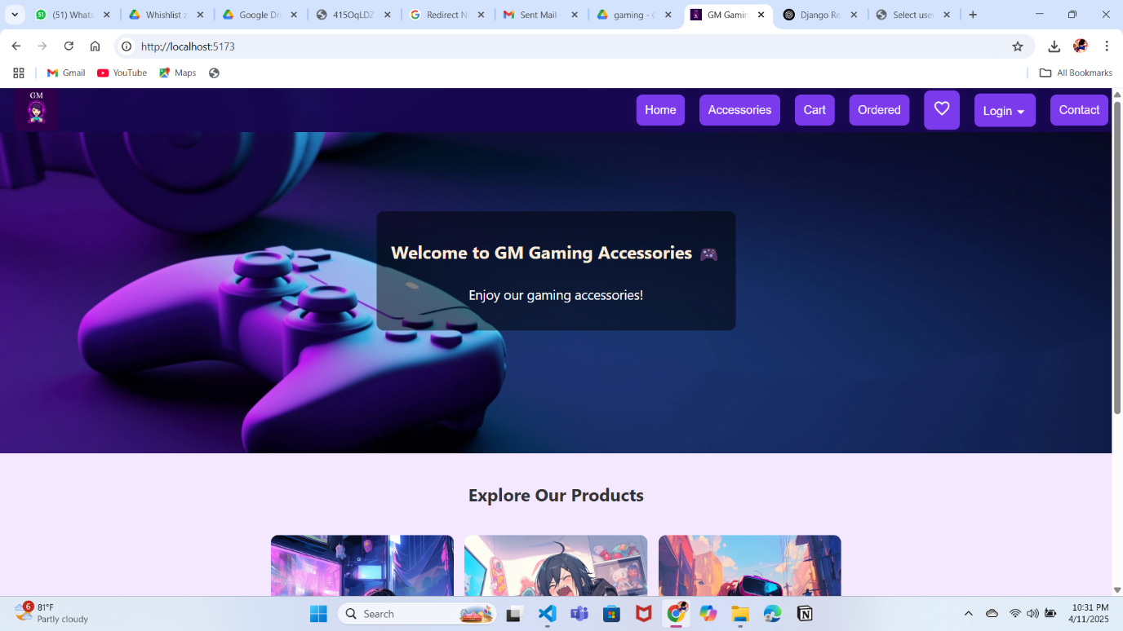

Labels and Badges: Labels or badges indicating “New Arrival,” “Best Seller,” or “Discount” can be applied to products to highlight special items. These visual cues help guide users toward popular or high-value products.

Filter Options: The category page includes a set of filters that allow users to narrow down their search based on various criteria such as price range, brand, size, color, and customer ratings. Filters are typically located in a sidebar or dropdown menu for easy access.

Search Within Category: An additional search bar may be provided within the category page to allow users to refine their search results without leaving the page. This feature is particularly useful for categories with a large number of products.

**4.1.3 PRODUCT AND DESCRIPTION PAGE:**

Product Title and Overview: The product title is prominently displayed at the top of the page, followed by a brief overview or tagline that summarizes the product's main selling points. The title should be clear, descriptive, and include relevant keywords for SEO purposes.

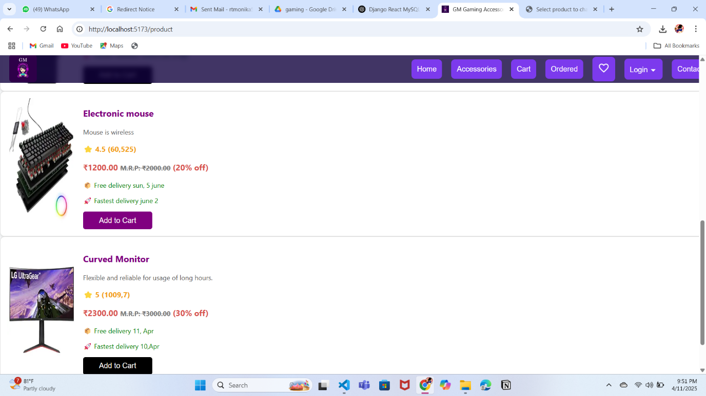

**4.1.4 MY ORDERS PAGE:**

The My Orders page is a key user-centric feature of the eCommerce website, allowing users to save and manage products they are interested in but may not be ready to purchase immediately. This functionality enhances the overall shopping experience by providing convenience, personalization, and improved product discoverability.

The My orders page gives the ordered items and helps in filtering the products using username or product id.

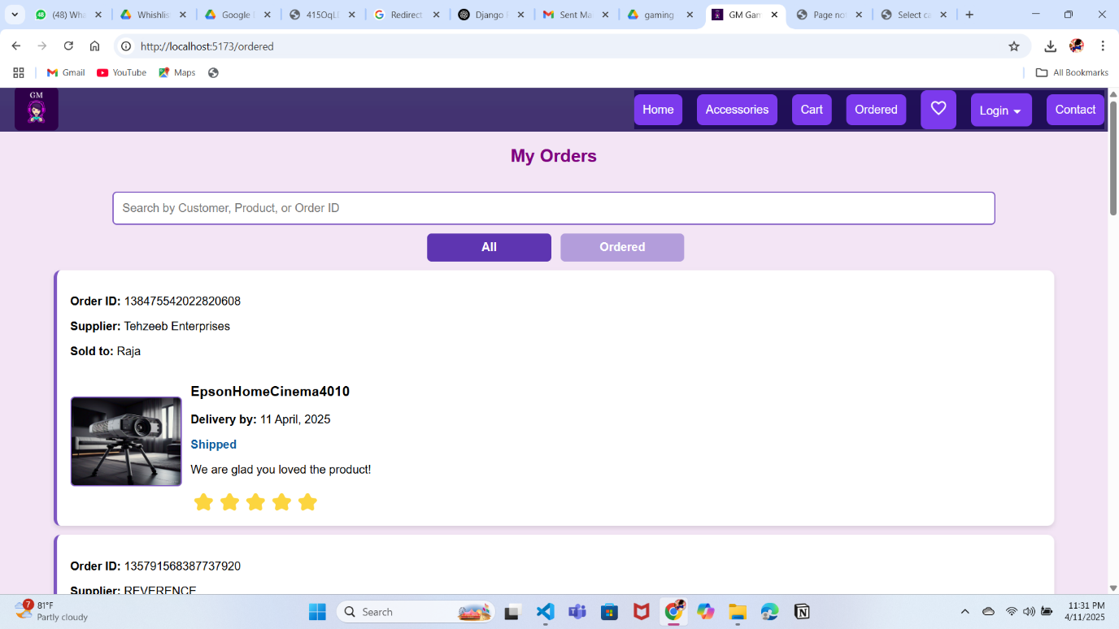

**4.1.5 ADD TO CART PAGE:**

The **Add to Cart** page plays a central role in the user journey on the eCommerce platform, acting as a bridge between product selection and checkout. It allows users to review and manage the gaming accessories they intend to purchase before proceeding to payment.

The primary purpose of the Add to Cart page is to offer users a clear summary of their selected items and give them full control over quantities, item removal, and navigation to checkout. It contributes directly to the overall conversion rate and user satisfaction.

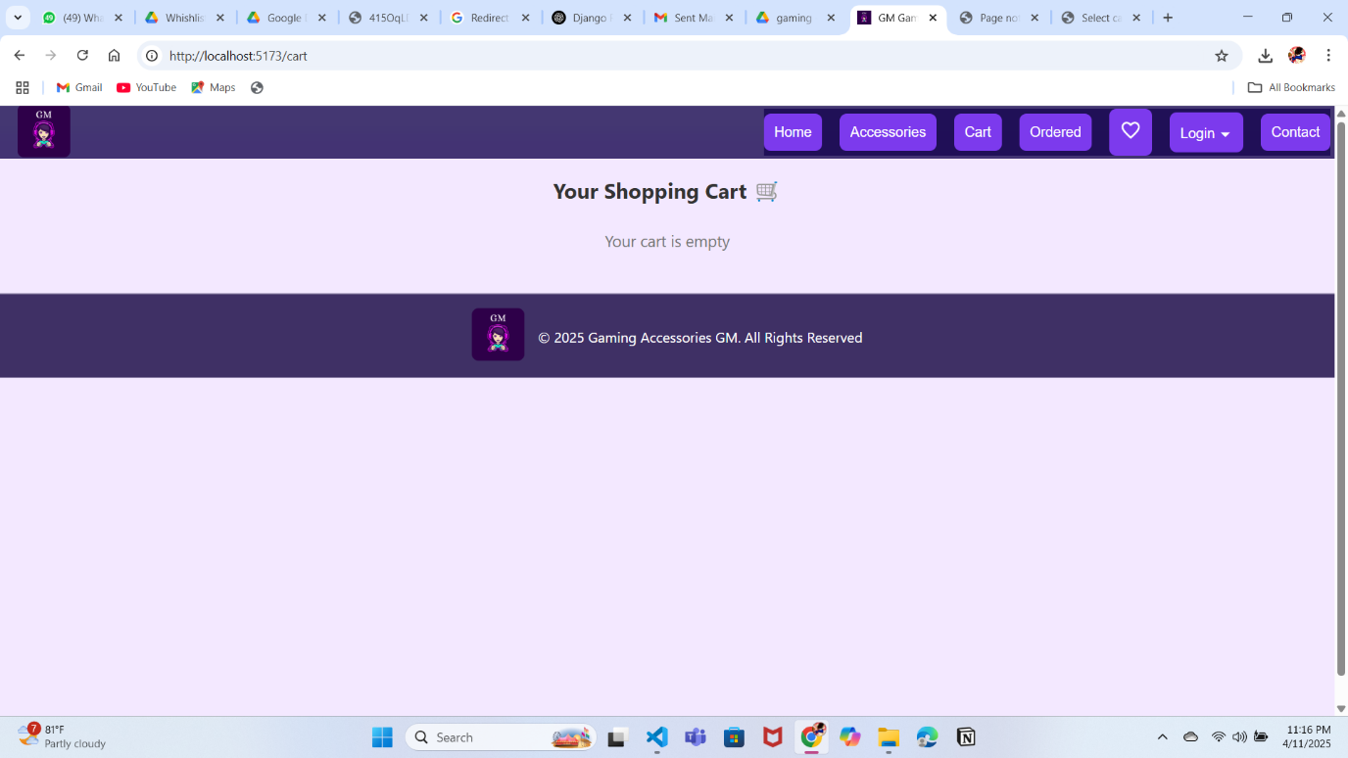

**4.1.6 DATABASE PAGE:**

The database is the backbone of the eCommerce website, responsible for securely storing, retrieving, and managing all data related to users, products, orders, and website functionality. It ensures that the platform runs smoothly, maintains data integrity, and supports real-time transactions and dynamic content delivery.

The primary role of the database is to provide structured storage and efficient access to all critical information required by the website. It supports both the front-end (user interactions) and the back-end (administrative tasks) of the system.

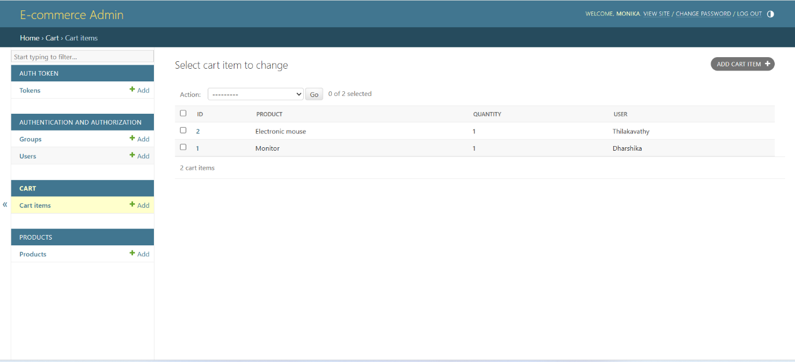

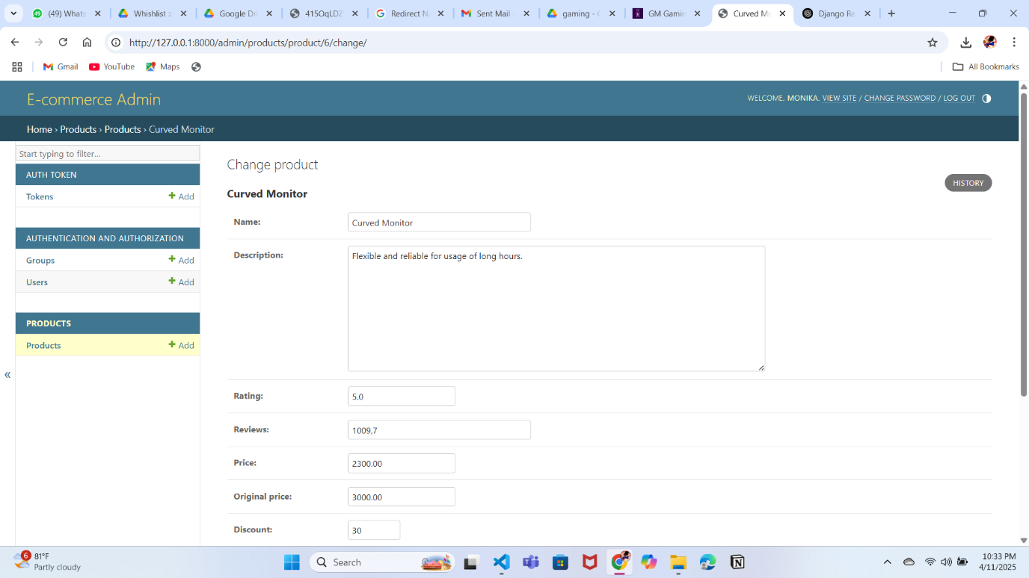

**4.1.8 ORDER CONFIRMATION PAGE:**

The **Order Confirmation** page is a key step in the eCommerce user journey, presented immediately after a successful transaction. It reassures customers that their order has been placed correctly and provides a summary of essential details for future reference.

The main purpose of the Order Confirmation page is to confirm that the order has been successfully processed and to provide the customer with a clear summary of their purchase. It acts as both a receipt and a transition point into the post-purchase phase (tracking, delivery, support).

**SKILLS ACQUIRED**

**1. Technical Skills**

Developing a fully functional and responsive website using HTML, CSS, JavaScript, MongoDB, and React.js requires a solid understanding of various technical concepts and tools across both the frontend and backend domains. The following technical skills are essential:

#### **1. HTML (HyperText Markup Language)**

* Writing semantic HTML5 elements for page structure and accessibility.
* Creating forms, tables, navigation menus, and multimedia content.
* Organizing content hierarchically for SEO optimization.

#### **2. CSS (Cascading Style Sheets)**

* Styling web pages using selectors, properties, and values.
* Responsive design using Flexbox, Grid Layout, and media queries.
* Creating smooth user interface effects using CSS animations and transitions.
* Familiarity with class-based and ID-based styling for component-based design.

#### **3. JavaScript**

* Understanding the core language (variables, data types, loops, functions, objects).
* DOM manipulation to update and control HTML/CSS dynamically.
* Event handling for interactivity (e.g., click, hover, submit).
* Working with modern JavaScript features (ES6+): arrow functions, template literals, destructuring, etc.
* Handling asynchronous operations using Promises, fetch(), and async/await.

#### **4. React.js**

* Creating reusable components using JSX.
* Managing state and side effects with React Hooks (useState, useEffect).
* Using React Router for single-page application navigation.
* Passing data using props and managing component lifecycles.
* Implementing dynamic rendering based on user interactions and state changes.

#### **5. MongoDB (Database)**

* Designing and managing NoSQL databases using collections and documents.
* Performing CRUD operations (Create, Read, Update, Delete).
* Writing MongoDB queries to retrieve and manipulate data.
* Understanding schema design, indexing, and relationships in a NoSQL context.
* (Optional) Using Mongoose to connect MongoDB with Node.js/Express applications.

#### **6. Additional Technical Tools**

* **Git & GitHub:** Version control for tracking changes and collaborating on code.
* **API Integration:** Fetching data from external or internal APIs and displaying it in the frontend.
* **Deployment Tools:** Hosting the website on platforms like Vercel, Netlify, or GitHub Pages.
* **Browser Developer Tools:** Debugging layout and script issues efficiently.

**Soft skills:**

While technical expertise is crucial in website development, soft skills play an equally important role in ensuring successful project execution, teamwork, and continuous improvement. The following soft skills are essential when working with technologies like HTML, CSS, JavaScript, MongoDB, and React.js:

#### **1. Problem-Solving**

* Ability to troubleshoot bugs, debug code, and find logical solutions efficiently.
* Applying analytical thinking to optimize design and code performance.

#### **2. Attention to Detail**

* Ensuring clean, well-structured code and visually consistent layouts.
* Avoiding small errors that can lead to larger issues in design or functionality.

#### **3. Communication**

* Explaining technical ideas clearly to team members, clients, or non-technical stakeholders.
* Collaborating effectively in teams, whether in-person or remote.

#### **4. Time Management**

* Prioritizing tasks effectively to meet deadlines and project milestones.
* Balancing development, testing, and documentation phases within set timelines.

#### **5. Creativity and Design Thinking**

* Applying innovative thinking to create user-friendly and engaging interfaces.
* Designing intuitive layouts that enhance user experience (UX) and functionality.

#### **6. Adaptability and Willingness to Learn**

* Keeping up with rapidly evolving tools, libraries, and best practices in web development.
* Adjusting quickly to new challenges, feedback, or changing project requirements.

#### **7. Teamwork and Collaboration**

* Working collaboratively on shared codebases using Git or version control tools.
* Participating in code reviews, brainstorming sessions, and project discussions.

#### **8. Critical Thinking**

* Evaluating multiple solutions and choosing the most efficient or scalable approach.
* Anticipating potential issues and proactively designing for reliability and security.

**CONCLUSION:**

The internship at WORKCO Solutions was a pivotal experience in my career development. My internship experience has been both rewarding and educational, offering me valuable insights into the development of an e-commerce website and the dynamics of a professional work environment. Working closely with a team of skilled professionals, I gained hands-on experience in various aspects of website development, including front-end design, back-end programming, and user experience optimization. This practical exposure has significantly enhanced my technical skills and deepened my understanding of the ecommerce industry.

One of the most impactful aspects of my internship was the company’s friendly and collaborative environment. From day one, I was welcomed as part of the team and encouraged to contribute my ideas. The culture of continuous learning and support allowed me to ask questions, seek guidance, and take on tasks that challenged me to grow. This environment not only made my internship enjoyable but also enriched my learning experience, as I was able to engage with complex problems and see projects through from start to finish.

Overall, this internship has been a pivotal step in my professional development. I have gained practical skills, learned to navigate a real-world work environment, and experienced firsthand the importance of a positive company culture. The knowledge and experience I have acquired will undoubtedly serve as a strong foundation for my future career in the industry.